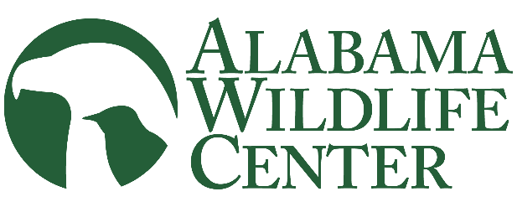

Clinic Director

Overview:
The Clinic Director provides leadership and direction for AWC’s avian rehabilitation clinic. This position will play a key role in modernizing clinic operations, improving systems and procedures, and maintaining high standards of animal care. The Clinic Director will guide and support staff and volunteers while helping move the clinic into its next chapter.

Duties:
- Provides overall leadership and oversight of AWC’s wildlife rehabilitation program and clinic operations.
- Supervises and develops clinic staff, interns, and volunteers, and ensures appropriate staffing and coverage for a 365-day animal care operation.
- Oversees patient care and rehabilitation, including admissions, treatment, release, transfer, and euthanasia decisions, while working closely with staff, veterinarians, and other professional partners.
- Establishes and maintains clinic protocols, training standards, and expectations to ensure consistent, high-quality animal care and appropriate patient capacity.
- Evaluates and improves clinic workflow, recordkeeping, communication, and other systems to increase efficiency and reduce unnecessary waste.
- Ensures standards for animal care, sanitation, safety, organization, and documentation are consistently maintained.
- Oversees clinic supplies, equipment, purchasing, and other resources within the approved budget.
- Maintains required federal and state records, reports, permits, and regulatory compliance, and uses clinic data to evaluate performance and guide improvements.
- Builds and maintains relationships with veterinarians, wildlife rehabilitators, agencies, and other professional partners.
- Works with the Executive Director and Development staff on clinic funding needs, grant opportunities, and implementation of funded projects.
- Participates in hiring, evaluations, coaching, and performance management of clinic staff and represents AWC through conferences, programs, media, and other public-facing opportunities.
- Performs other duties as needed to support AWC’s wildlife rehabilitation program.
Qualifications:
- Demonstrated leadership, supervisory, and team-development skills.
- Experience in wildlife rehabilitation, veterinary care, animal care, clinical operations, or a related field.
- Strong organizational, problem-solving, and decision-making skills, with the ability to manage a fast-paced 365-day operation.
- Excellent interpersonal, written, and public communication skills.
- Relevant degree, certification, or advanced training preferred, but not required.

